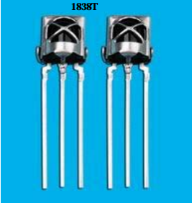

1. characteristic:

●Small design;

●Built-in dedicated IC;

●Wide angle and long distance reception;

●Strong anti-interference ability;

●It can resist the interference of the environment and the light;

●Low voltage work;

2. application:

■Audio-visual equipment (speakers, TVs, video recorders, disc players)

■Household appliances (air conditioners, electric fans, electric lights)

■Other infrared remote control products;

3．size：

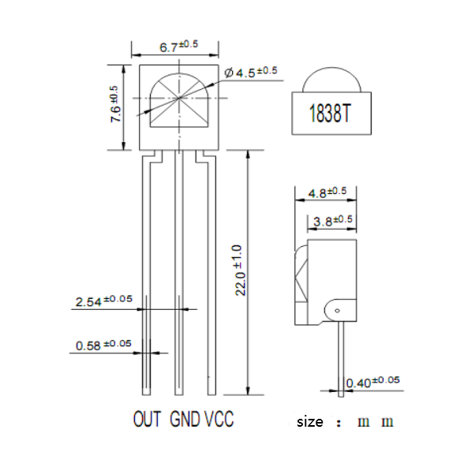

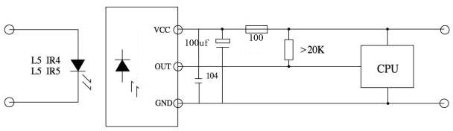

Model: 1838T

4．Application circuit diagram:

5．Schematic diagram:

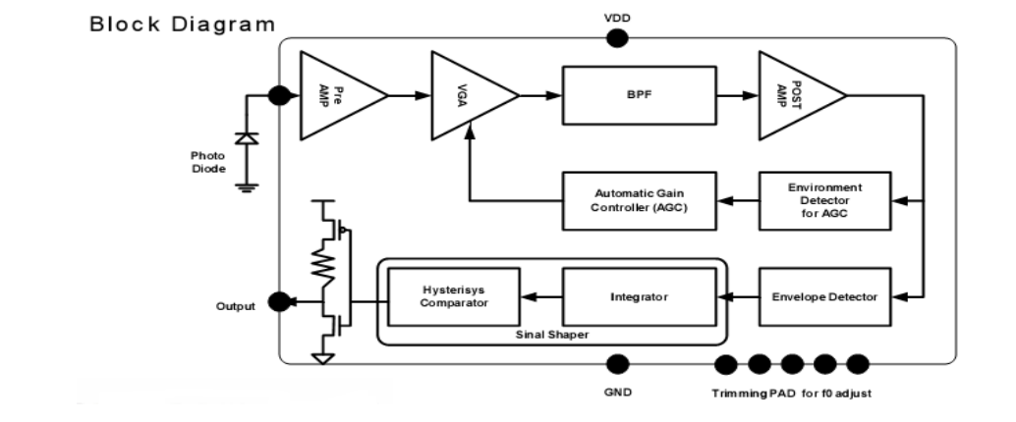

6．Optical parameters(T=25℃ Vcc=5v f0=38KHZ)：

|  |  |  |  |  |  |  |
| --- | --- | --- | --- | --- | --- | --- |
| Parameter | symbol | Test Conditions | Min | Type | Max | Unit |
| Operating Voltage | VCC |  | 2.7 |  | 5.5 | V |
| Working current | Icc |  | 0.6 | 0.8 | - | mA |
| Quiescent Current | Ice | 无信号输入时 | 0.1 |  | 0.5 | mA |
| Receiving distance | L | ※ | 22 | 25 |  | M |
| Receiving angle | θ1/2 |  | +/-35 | | | Deg |
| Carrier frequency | f0 |  |  | 38 |  | KHZ |
| BMP Width | fBW | -3Db Bandwidth | - | 8 | - | kHz |
| Low level output | VOL | Vin=0V Vcc=5V |  |  | 0.4 | V |
| High level output | VOH | Vcc=5V | Vcc-0.3 |  | Vcc | V |
| Output pulse width | TPWL | Vin=50mVp-p | 500 | 600 | 700 | μS |
| TPWH | Vin=50mVp-p | 540 | 640 | 740 | μS |

※ Test on the optical axis, with a width of 600/900μs as the transmitted pulse, within the receiving range of 5CM, take the average of 50 received pulses。

# Model: 1838T

7．Test waveform:

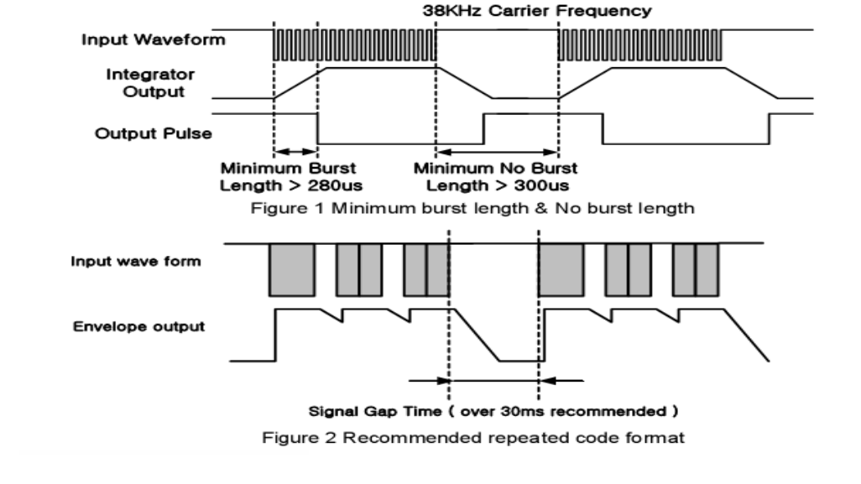

8．Characteristic curve(Characteristics Curve)(Tamb=25℃ unless otheruise specified)：

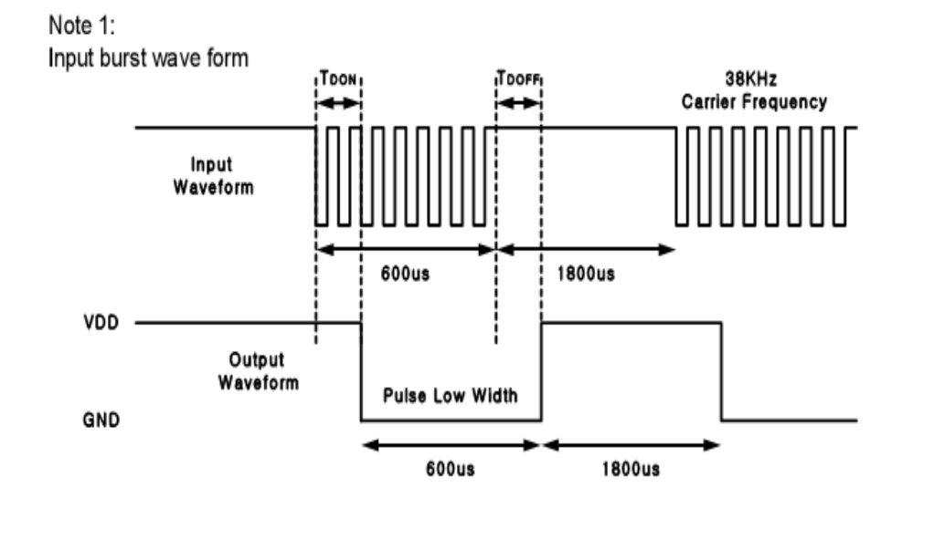

# 型号: 1838T

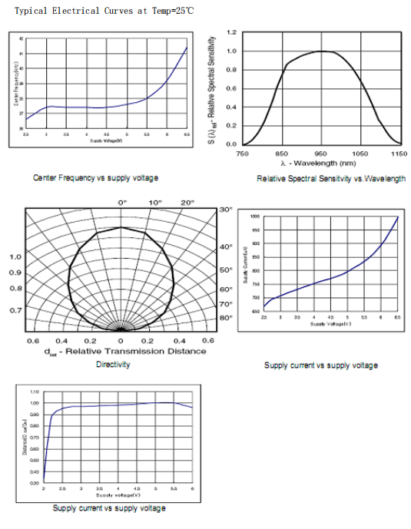

# 型号: 1838T

9．Limit parameters:

|  |  |  |  |
| --- | --- | --- | --- |
| **Item** | **symbol** | **specification** | **unit** |
| **Supply voltage** | VCC | -0.3—6.5 | V |
| **Operating temperature** | Topr | -20— +85 | ℃ |
| **Storage temperature** | Tstg | -40 —— +125 | ℃ |
| **Welding temperature** | Tsol | 260（5S） | ℃ |

10．Recommended use conditions:

|  |  |  |  |  |  |
| --- | --- | --- | --- | --- | --- |
| **item** | **symbol** | **Min** | **Typ** | **Mnx** | **unit** |
| **Supply voltage** | Vcc | 2.7 | ----- | 5.5 | V |
| **Input frequency** | FM |  | 38 |  | kHz |
| **Operating temperature** | Topr | -20 | 25 | 80 | ℃ |

11．Receiving angle diagram:

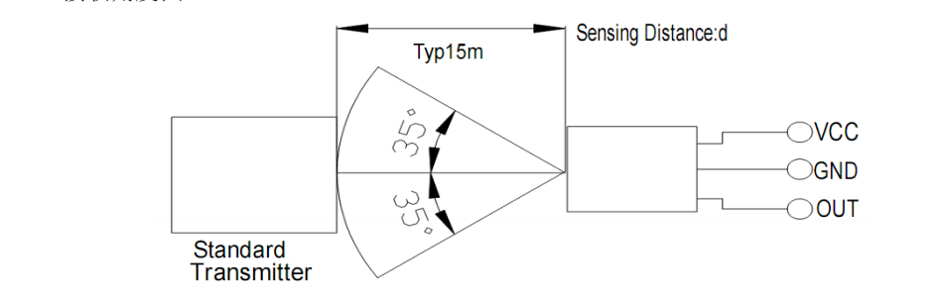

12. Use note:

1). Store and use in an environment that does not have any external pressure and affects quality;

2). Store and use in an environment where there is no pollution gas or sea breeze (salinity);

3). Store and use in a low humidity environment;

4). Solder the lead pins under the specified conditions, after soldering, do not apply external force;

5). Do not clean this product. Before use, please connect the operator and the soldering iron to the floor wire with an electrostatic belt;

6). Please pay attention to protect the receiving surface of the infrared receiver. Contamination or wear will affect the receiving effect, and do not touch the surface.